**rajma recipe, how to make rajma masala | easy punjabi rajma recipe**[**Indian Mother Loses 24kg in 2 Months With This New Diet Pill... (MGID)**](http://www.mgid.com/ghits/1266163/i/1187/0/src/%5beng_int_sub_id%5d/pp/18/1/?h=53pmS2rwYg-iiQwaRfBT5JjaV97FtllZos8wQz5AHD2xRXLuYchKe5-SxemYcQcU)

[**The Most Beautiful Girls In India (MGID)**](http://www.mgid.com/ghits/1284888/i/1187/0/src/%5beng_int_sub_id%5d/pp/4/1/?h=53pmS2rwYg-iiQwaRfBT5M34I94lkBZOlhF-thgVaeDR5iSviypFy6siy3rpkiMa)

[**This Glowing Bicycle Path Inspired By Van Gogh’s “Starry Night” Is Stunning! – BuzzWok (Buzzwok)**](http://www.buzzwok.com/this-glowing-bicycle-path-inspired-by-van-goghs-starry-night-is-stunning)

[**Polish Photographer Takes The Most Amazing Portraits Of Dogs! Truly Magical. (Buzzwok)**](http://www.buzzwok.com/polish-photographer-takes-the-most-amazing-portraits-of-dogs-truly-magical)

[**A Simple Weight Loss Trick Of Bollywood (MGID)**](http://www.mgid.com/ghits/1290821/i/1187/0/src/%5beng_int_sub_id%5d/pp/1/1/?h=53pmS2rwYg-iiQwaRfBT5Mj00gY973mLds3s3Dzb46769cvlqY2cRgD6Ahw_k5hd)

[**Sony Xperiya C At The Best Price Online! (MGID)**](http://www.mgid.com/ghits/1284721/i/1187/0/src/%5beng_int_sub_id%5d/pp/5/1/?h=53pmS2rwYg-iiQwaRfBT5O3ngdiQNTa9lO8OE3VrmYuxeVj8k3JHGxxezTl-cip9)

[**Senior Women With Tattoos Show That Aging With Tattoos Looks Pretty Good! | BuzzWok.com | The Best Buzzing Stories Frying In One Place (Buzzwok)**](http://www.buzzwok.com/senior-women-with-tattoos-show-that-aging-with-tattoos-looks-pretty-good/)

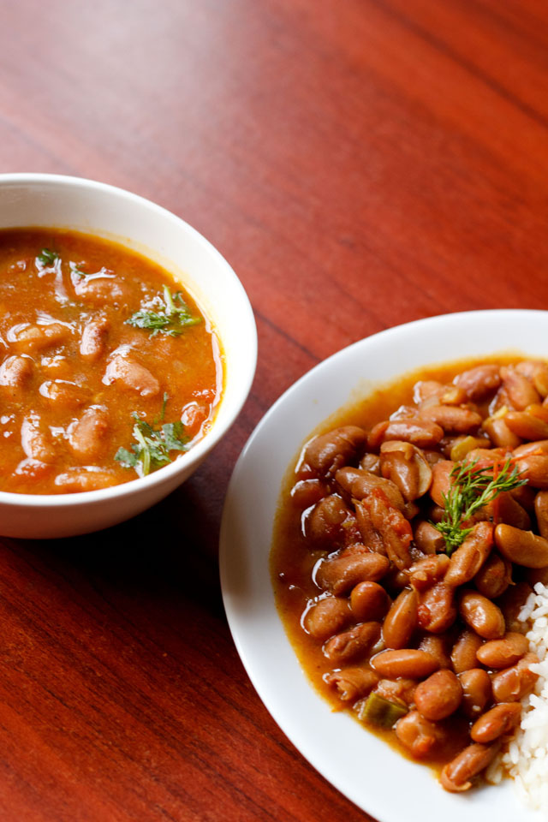

Rajma masala or rice is one of the delicious and famous recipe at any Punjabi family or Jammu Kashmir. It’s her extraordinary recipe and it is extraordinary in one more sense. It’s actually, simple and easy recipe. Overall a delicious easy rajma masala or curry.

no grinding, no frying of anything so that they take less time to cook this homely recipe is mildly spiced and not heavy as no cream is used. overall a delicious easy rajma curry.

soak 1 cup (200 grams) rajma beans in enough water overnight or for 8 to 9 hours. the next day or after 8 to 9 hours, drain the soaked water. rinse the rajma beans again in fresh clean water. drain them and keep aside. chop the veggies – 1 large onion (1oo gms), 3 medium tomatoes (200 gms), 1 inch ginger, 7 to 8 medium sized garlic and 1 green chili. keep aside. in a pressure cooker add the rajma along with the chopped onions, tomatoes, ginger, garlic and green chilies. now add the spices – 1 tsp cumin seeds, ½ tsp red chili powder, ½ tsp turmeric powder and salt.pour 2.5 cups water (625 ml).stir very well. add 2 tbsp butter or oil.stir again. cover tightly and pressure cook for 18 to 20 whistles on a high flame. once the pressure settles down on its own, open the lid and check the beans. the rajma has to be cooked completely. taste a few beans and they should be melt in the mouth without giving you any bite or resistance while eating. if the beans are still not cooked completely, then add about 1/2 cup more of water and pressure cook again for 5 to 6 whistles or as required.once the rajma are cooked well, then check the gravy or curry also. you will see thin water like stock with the tomatoes and onions floating. so you have to continue to simmer the rajma masala till the curry thickens a bit.keep the cooker on stove top without lid and on a low to medium flame to simmer the gravy.when you keep the curry on the stove top, then add 1 tsp [dry mango powder/amchur](http://www.vegrecipesofindia.com/amchur-powder-recipe-dry-mango-powder/).add about ¾ to 1 tsp [garam masala powder](http://www.vegrecipesofindia.com/punjabi-garam-masala/). stir well and simmer the rajma curry till its consistency thickens. mash a few rajma beans with the back of a spoon to thicken the consistency. when the consistency of the curry is no longer broth like or water like and thickened somewhat like the one shown in the pic below. then the rajma masala is ready. if you want you can thicken the gravy more, if having with chapatis or phulkas. lastly check the taste and add more of salt, garam masala, red chili powder or dry mango powder if required. garnishing rajma masala with coriander leaves is optional. **serve rajma masala** with some steamed rice or with [rotis](http://www.vegrecipesofindia.com/rotis-made-from-whole-wheat-flour/), [parathas](http://www.vegrecipesofindia.com/paratha-recipe-plain-paratha-recipe/) or [bread](http://www.vegrecipesofindia.com/100-whole-wheat-bread-atta-bread/).

**punjabi rajma masala recipe below:**

4.5 from 12 reviews

rajma recipe

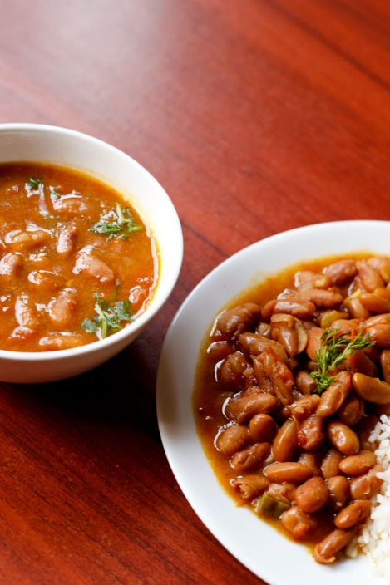

1 cup rajma/red kidney beans, about 200 gms, dripping instant in plenty water, 2.5 cups water for cooking, 1 green chili, sliced, 1 table spoon sliced garlic ½ inch ginger, 1 tablespoon chopped ginger 7 to 8 medium garlic, 3 medium tomatoes cut, about 200 gms, 1 large onion cut, about 100 gms, ½ tsp turmeric powder, ½ tsp red chili powder, ¾ to 1 tsp garam masala powder, 1 tsp amchur powder, 1 tsp cumin seeds, 2 table spoon butter or oil, salt as required.

**INSTRUCTIONS**

Rajma beans for a combine of times in running water, then saturate the rajma beans in plentiful water overnight or for 8 to 9 hours, next day or next 8 to 9 hours, ditch the soaked water, again rajma beans in fresh water drain them and keep apart, chop the veggies onion, tomatoes, ginger, garlic and green chilies. keep apart in a pressure cooker add the rajma beside with the chopped onion, tomatoes, ginger, garlic and green chilies and add the spices cumin seeds, red chili powder, turmeric powder and salt as required pour water mix very well add butter or oil again mix it shield tightly and pressure cook for 18 to 20 whistles on a high flame, once the pressure calm down on its own, open the cover and check the beans, rajma has to be grilled completely, if the beans are still not cooked completely, then add about ½ cup more of water and cook again for 5 to 6 whistles, once the beans are cooked well, then check the gravy or curry also, you will see thin water like stock with the tomatoes and onions floating, so you have to continue to simmer the rajma masala till the curry thickens a bit, keep the cooker on stove top and on a low to medium flame, simmer without cap, mixing at intervals, when you keep the curry on the stove top, then add dry mango powder add garam masala powder also, mix well and simmer the curry till the consistency thickens, when the consistency of the curry is no longer broth like or water like and thickened, then the rajma masala is ready. if you want you can thicken the gravy more, if having with chapatis or phulkas, serve rajma masala with some steamed rice or with chapatis, parathas or bread.